16.35:
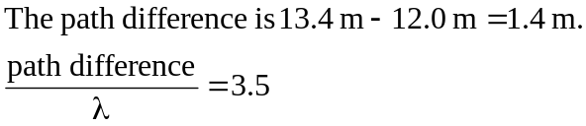
The path difference is a half-integer number of wavelengths, so the interference is destructive.

